Project Design Phase

Solu on Architecture

|  |  |
| --- | --- |
| Date | 1 July 2025 |
| Team ID | LTVIP2025TMID44259 |
| Project Name | Pattern Sense: Classifying Fabric Patterns using Deep Learning |
| Maximum Marks | 4 Marks |

Solu on Architecture:

Solu on architecture is a complex process – with many sub-processes – that bridges the gap between business problems and technology solu ons. Its goals are to:

* Find the best tech solu on to solve exis ng business problems.
* Describe the structure, characteris cs, behaviour, and other aspects of the so ware to project stakeholders.
* Define features, development phases, and solu on requirements.
* Provide specifica ons according to which the solu on is defined, managed, and delivered.

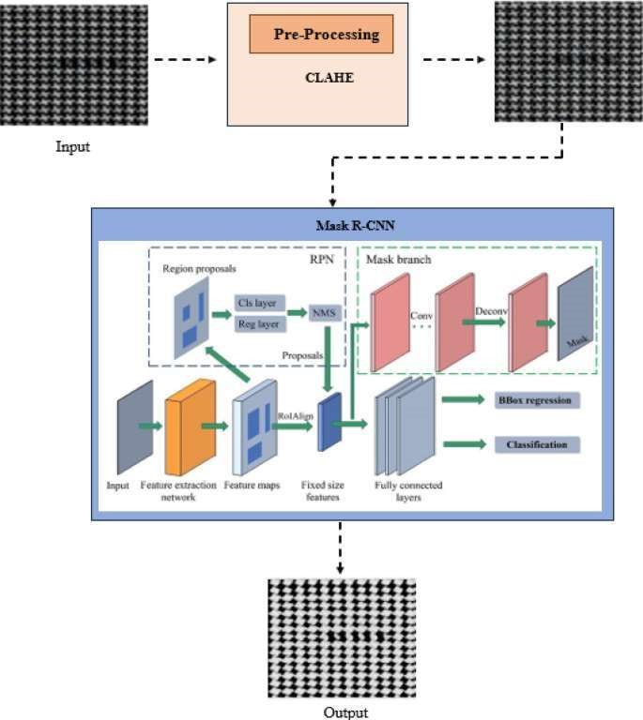

Reference: h ps://aws.amazon.com/blogs/industries/voice-applica ons-in-clinicalresearchpowered-by-ai-on-aws-part-1-architecture-and-design-considera ons/